**Soft166 - Web Design Document**

Trello: https://trello.com/b/dLYx4oXw/soft166

Git: https://github.com/Matt-Caine/Soft166

**Wire Frames**

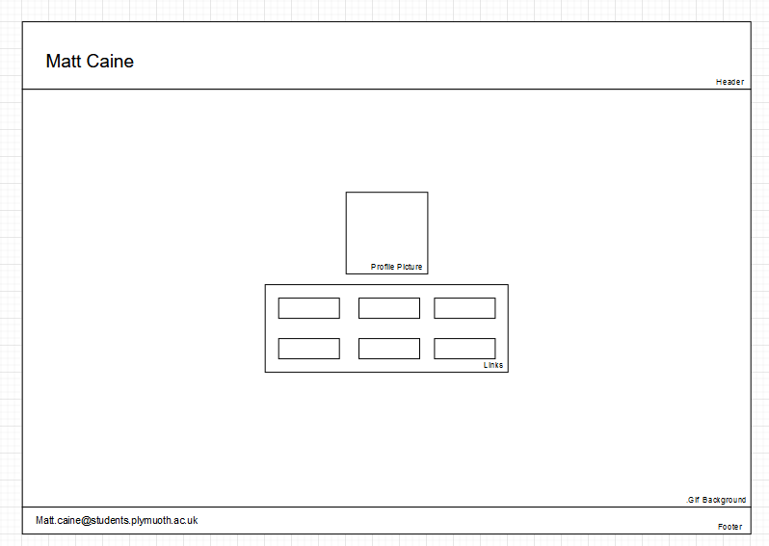

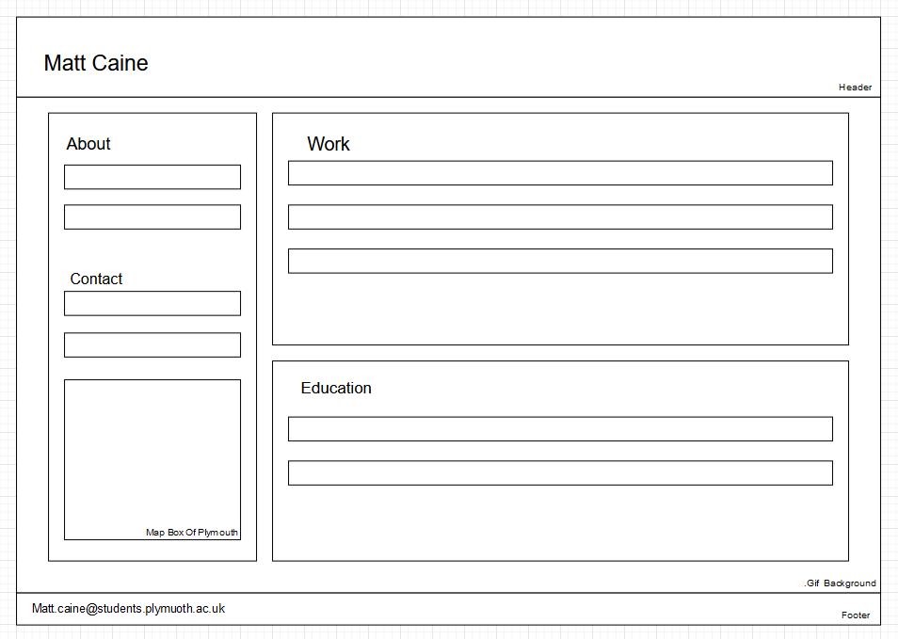

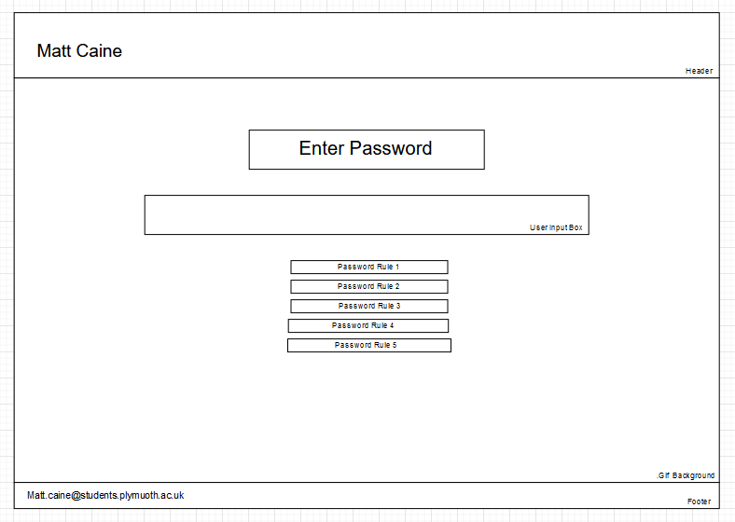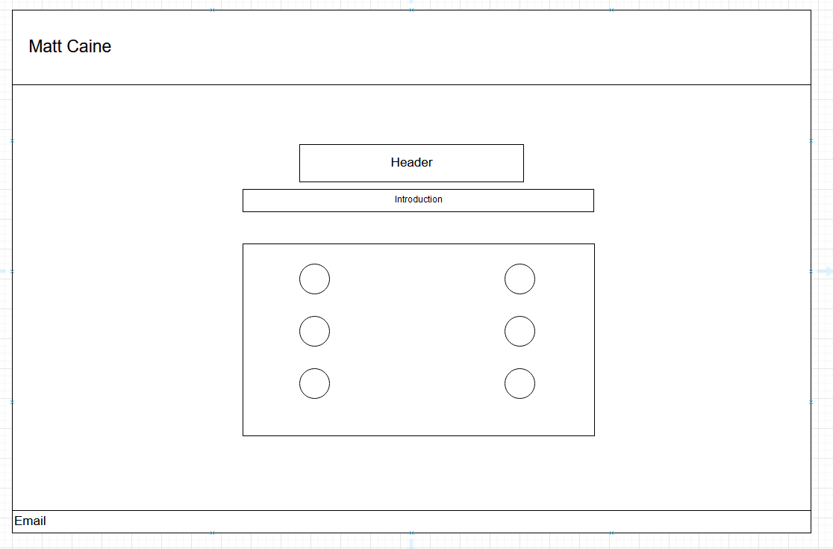

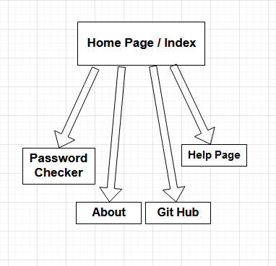**Site Map**

**Images**

